Thematic Unit Plan
Planning for Play that Builds on Students Bilingual Identities

Thematic Unit: ________________________________________________________________

Setting | Concept or Language to be Modeled through Play | Props that may elicit culturally & linguistically-specific creativity | What connection are there to students’ Communities?  How can Families contribute?
Kitchen Area
Dramatic Play Center
Block Area
(Art Table)
(Puppet Show Center)
(Table Manipulatives)

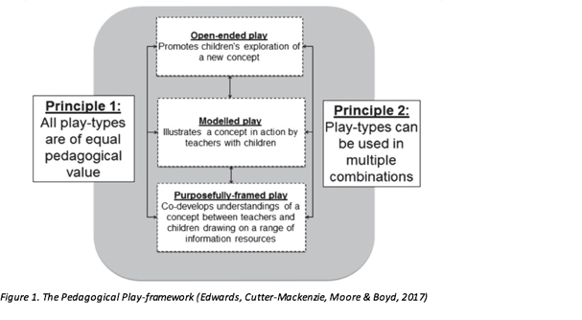

Figure 1. from Edwards, S. (June 2017). Play-based Learning and Intentional Teaching:
Forever Different? Australasian Journal of Early Childhood, 42(2).

